1. Amazon | OA 2020 | Utilization Checks

LeetCode : https://leetcode.com/discuss/interview-question/895097/

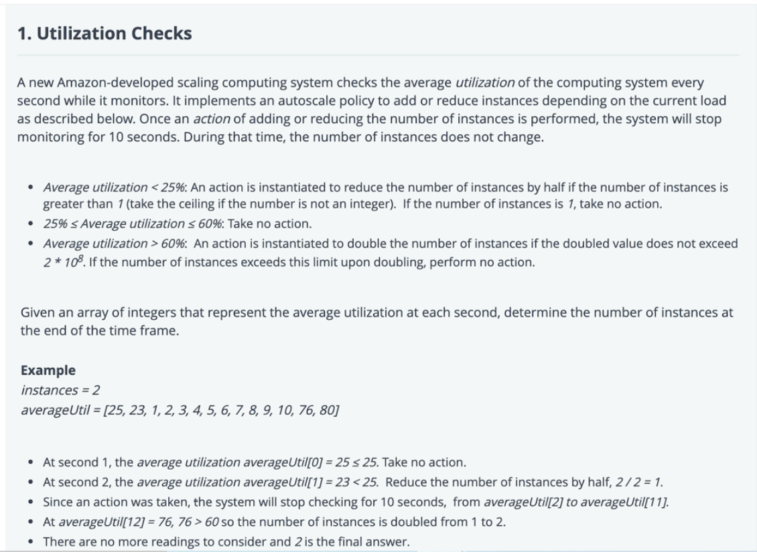

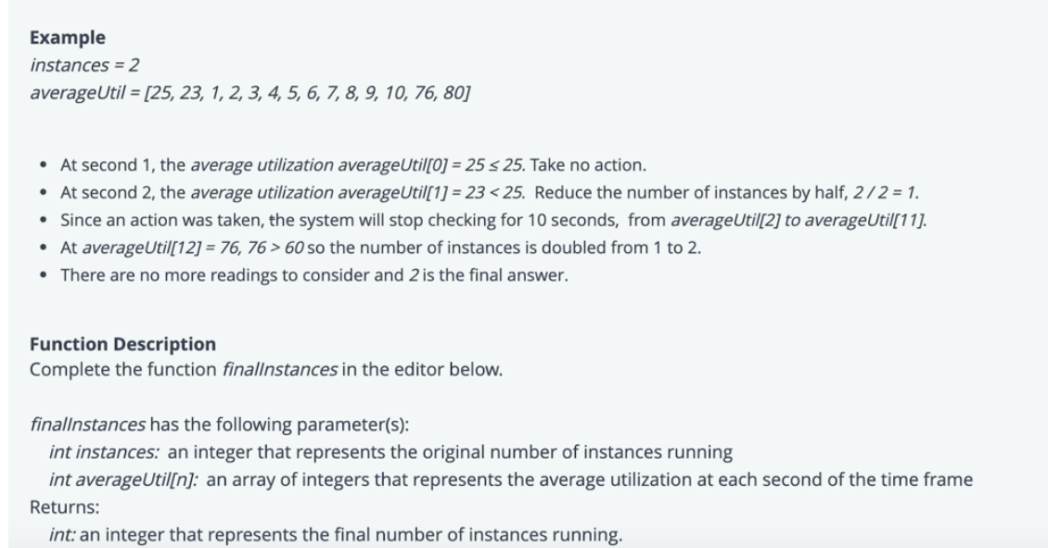

private static final int LIMIT = 2 * 100_000_000;

public static int finalInstances(int instances, List<Integer> averageUtil) {

for (int i = 0; i < averageUtil.size(); i++) {

int util = averageUtil.get(i);

if (util < 25) {

if (instances > 1) {

instances = instances / 2 + ((instances % 2 == 0) ? 0 : 1);

i += 10;

}

} else if (util > 60) {

int newInstances = 2 * instances;

if (newInstances <= LIMIT) {

instances = newInstances;

i += 10;

}

}

}

return instances;

}